<li class="disabled"><a href="#">CSS</a></li>  
<li class="active"><a href="#">HTML</a></li>

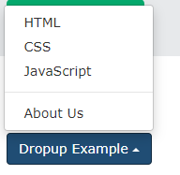

<div class="dropup">

<button class="btn btn-default dropdown-toggle"

type="button" data-toggle="dropdown">Dropup Example

<span class="caret"></span></button>

<ul class="dropdown-menu">

<li><a href="#">HTML</a></li>

<li><a href="#">CSS</a></li>

<li><a href="#">JavaScript</a></li>

<li class="divider"></li>

<li><a href="#">About Us</a></li>

</ul>

</div>